Promethean Product Matrix – What Works with What?
ActivBoards

 | Infrared ActivBoard | AB78 ActivBoard/ ProActivBoard | AB100 Series | AB 300 Series | AB300 PRO Series
General Information/Image | 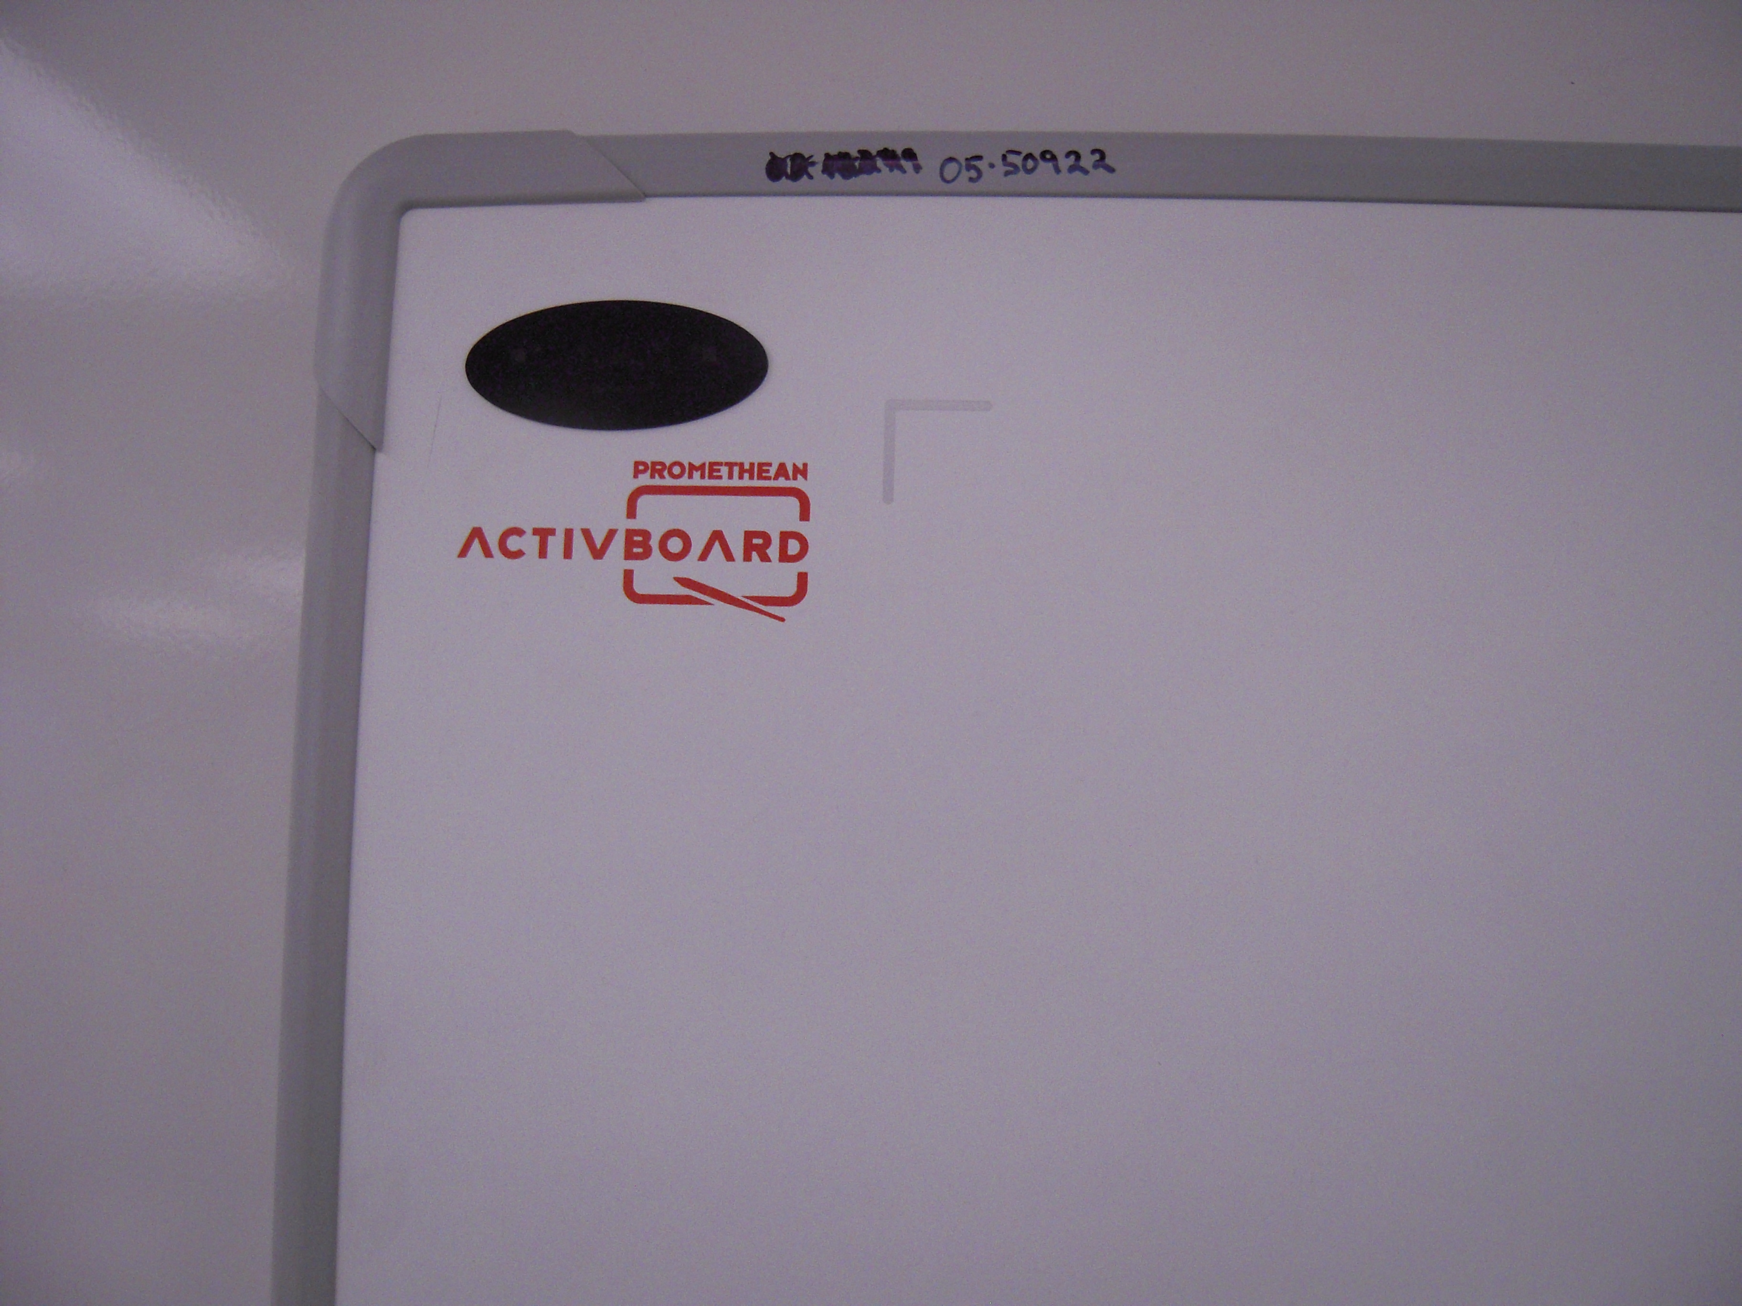 | 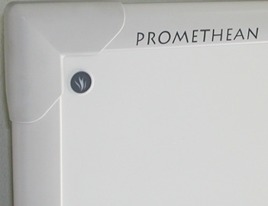 | 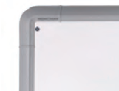 | 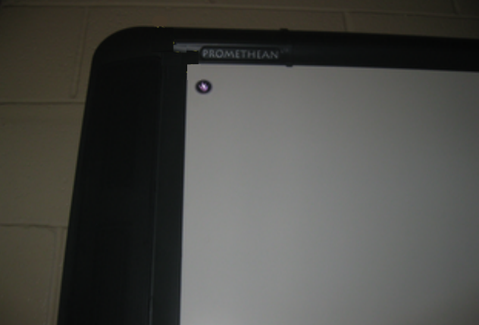 | 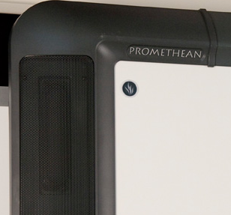
ActivPens

Which pens will work with which boards? | 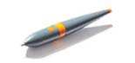 | ActivArena available as upgrade | ActivArena available as upgrade  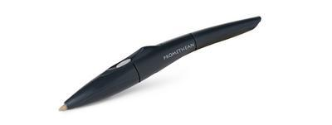 | ActivArena available as upgrade | ActivArena standard  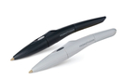
ActiVotes

AV2  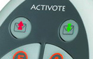  no wireless symbol between top buttons | Only w/ ActiVote-shaped Hub* or external transceiver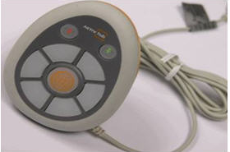 | Yes, with built in transceiver | Only w/ ActiVote-shaped Hub* | Only w/ ActiVote-shaped Hub* | Only w/ ActiVote-shaped Hub*
AV3  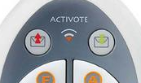  wireless symbol between top buttons | Yes, with black ActivHub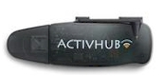 | Yes, with black ActivHub | Yes, with black ActivHub | Yes, with black ActivHub | Yes, with black ActivHub
ActivSlates

ActivSlate XR  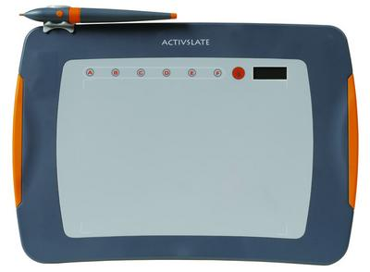 | Only w/ ActiVote-shaped Hub* or external transceiver | Yes, with built in transceiver | Only w/ ActiVote-shaped Hub* | Only w/ ActiVote-shaped Hub* | Only w/ ActiVote-shaped Hub*
ActivSlate 2.4 GHz  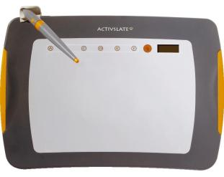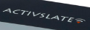 | Yes, with black ActivHub | Yes, with black ActivHub | Yes, with black ActivHub | Yes, with black ActivHub | Yes, with black ActivHub
ActivSlate 50  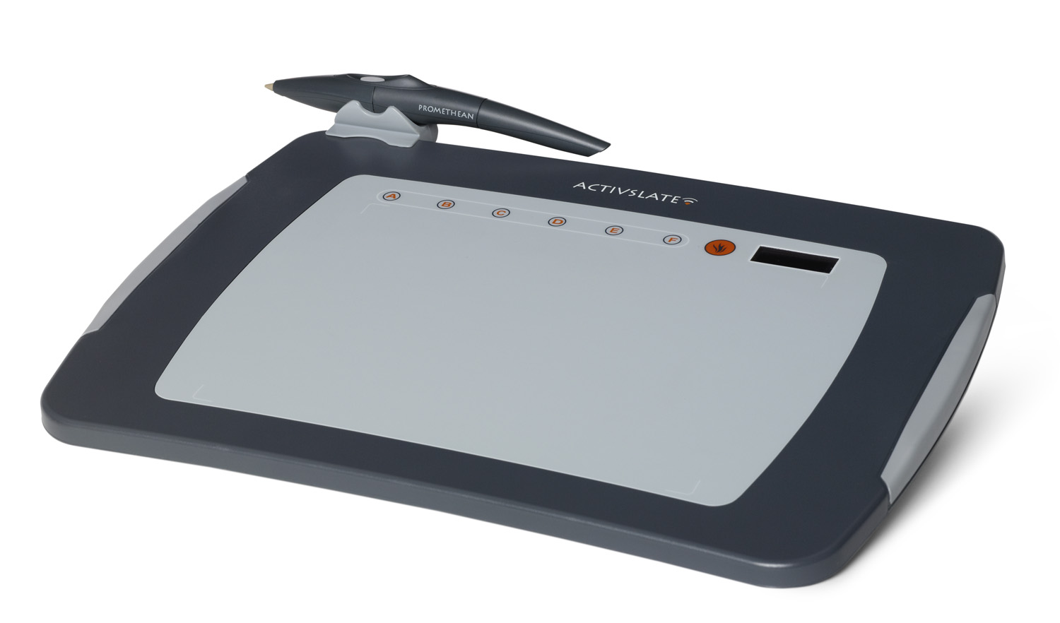 | Yes, with black ActivHub | Yes, with black ActivHub | Yes, with black ActivHub | Yes, with black ActivHub | Yes, with black ActivHub

Promethean Product Matrix – What Works with What?
ActivBoards

 | Infrared ActivBoard |  | AB78 ActivBoard/ ProActivBoard | AB100 Series | AB 300 Series |  | AB300 PRO Series
General Information/Image
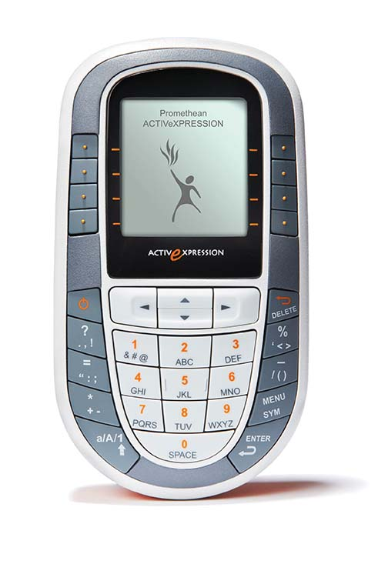 ActivExpressions

Expressions will work with all boards. All Expressions register to the
black ActivHub that is plugged into a USB port on the computer
ActivSoftware

ActivInspire  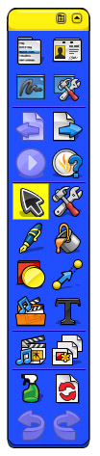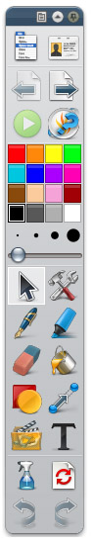 |  | All boards will work with ActivStudio, ActivPrimary or ActivInspire  The limitations for software depend on the computer  hooked up to the board.  Non-Intel Computers cannot run ActivInspire |  |  |  | ActivStudio/ActivPrimary  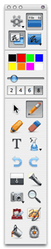

* Note – if you have both a legacy ActivHub and a newer black ActivHub plugged in simultaneously, only the black ActivHub will work be recognized.
Example 1: A teacher is trying to use a set of AV2 Activotes with legacy ActivHub simultaneously with 2.4Ghz ActivSlate registered to black ActivHub. The ActivSlate will override the ActiVotes because it is registered to the 2.4 GHz ActivHub.

Example 2: A teacher is trying to use their ActivSlate XR with legacy ActivHub simultaneously with ActivExpressions registered to black ActivHub. The ActivExpressions will override the ActivSlate because they are registered to the 2.4 GHz ActivHub.

